**Experiment No : 5**

Title: Running Node.js application over docker.

Aim : To run node.js application over docker.

Theory:

## What is Docker?

Docker is a software platform. It enables software developers to develop, ship and run applications within its containers. Containers are lightweight software applications. We are going to build a Docker image in this experiment.

## What is a docker file, image and container?

A docker file is a text file that contains the set of instructions for the Docker platform. Therefore, it can be versioned and committed to a code repository.

An image includes everything needed to run an application — the code or binary, runtime, dependencies, and any other file system objects required.

Docker containers run the application code.

we will create a simple web application in Node.js, then we will build a Docker image for that application, and lastly we will instantiate a container from that image.

Docker allows you to package an application with its environment and all of its dependencies into a "box", called a container. Usually, a container consists of an application running in a stripped-to-basics version of a Linux operating system. An image is the blueprint for a container, a container is a running instance of an image.

What Is Node.js?

Docker Node.js or simply, Node.js is an open-source software platform used to build scalable server-side and network applications. These Node.js applications are written in JavaScript and can run within this Node.js runtime on Linux, Windows, or Mac OS without changes. It was originally designed keeping in mind real-time and push-based architecture. Nowadays, it is primarily used for non-blocking, event-driven servers like backend API services and traditional websites.

Docker Node.js uses the Google V8 JavaScript to execute code and has its own built-in library for file, socket, and HTTP communication. This allows Node.js to act as a web server on its own without the support of additional software.

Prerequisites

To build an application, you need to have the following things in place:

* Node.js version 12.18 or later
* Docker running locally
* A text editor or IDE to edit your files

**Practical:**

1. **Docker File**

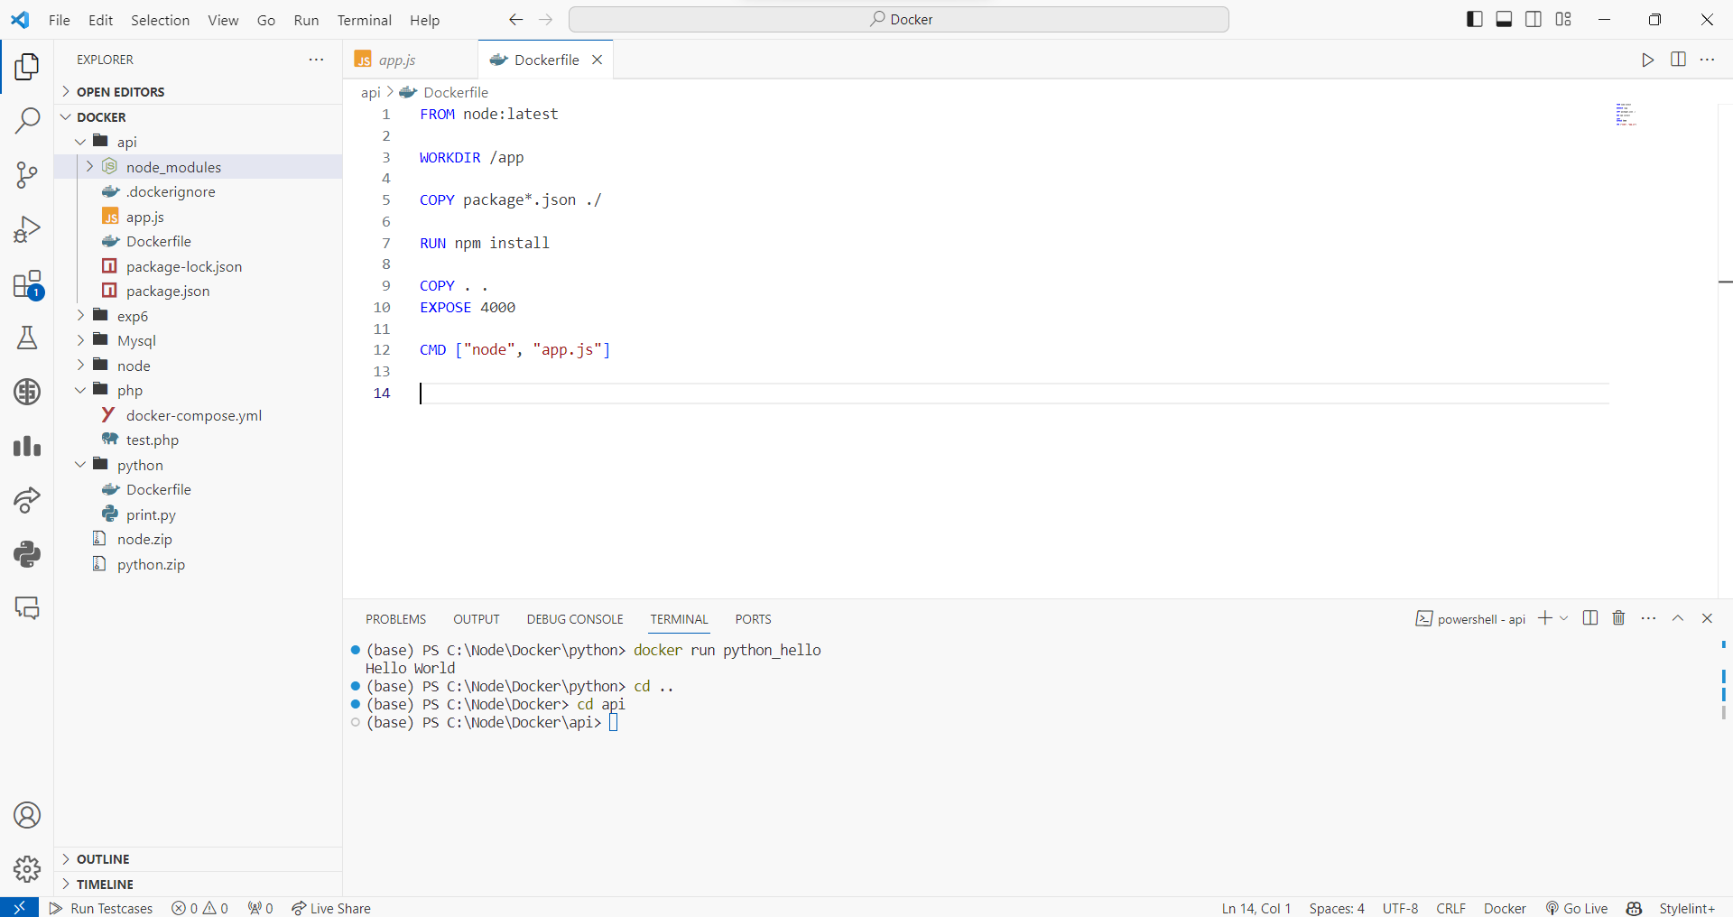

1. **Nodejs Server File**

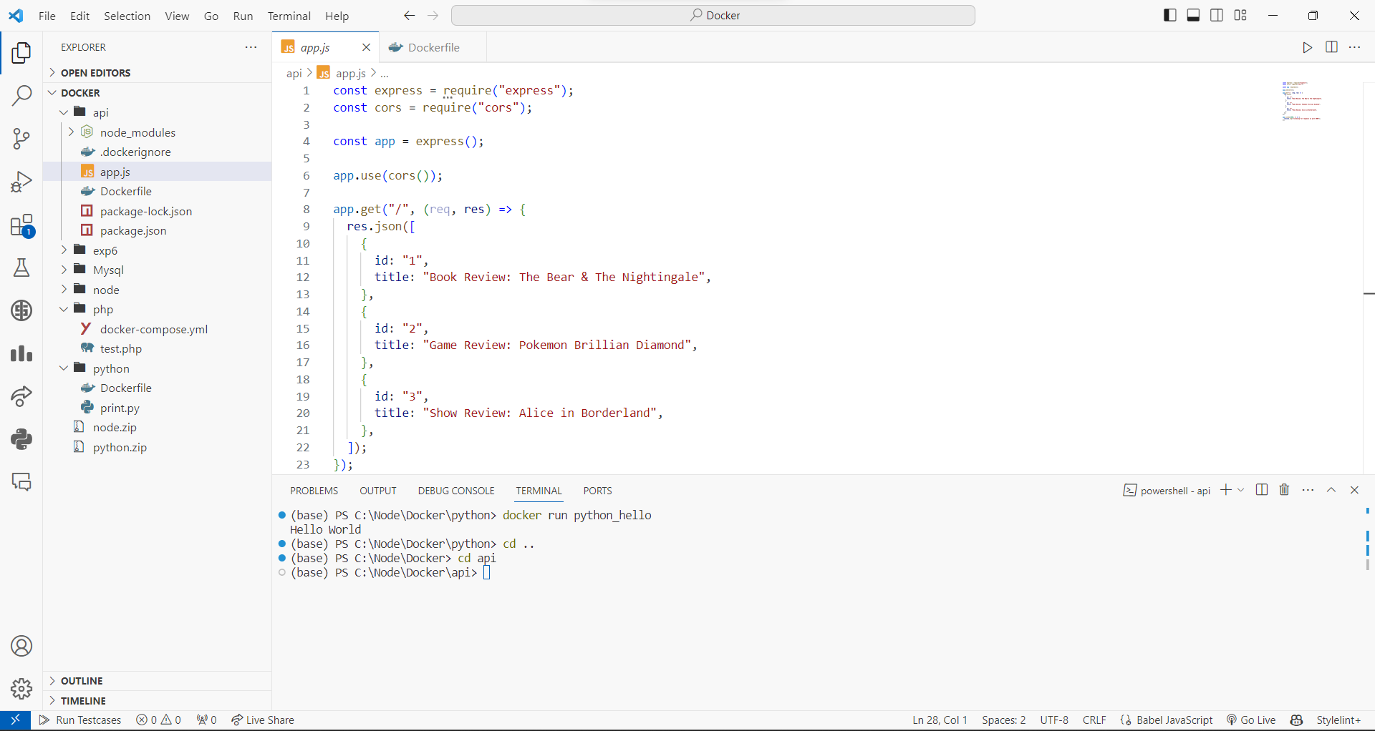

1. **Building Docker Image**

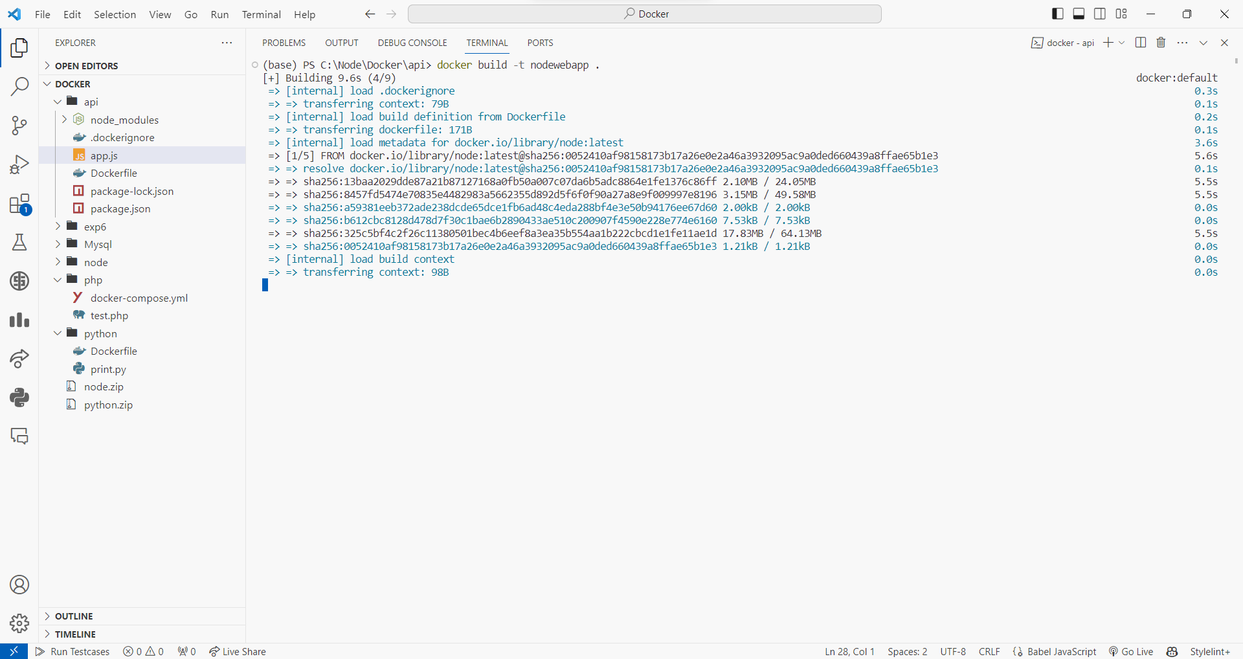

1. **Running Docker Image**

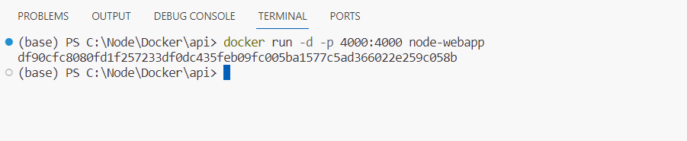

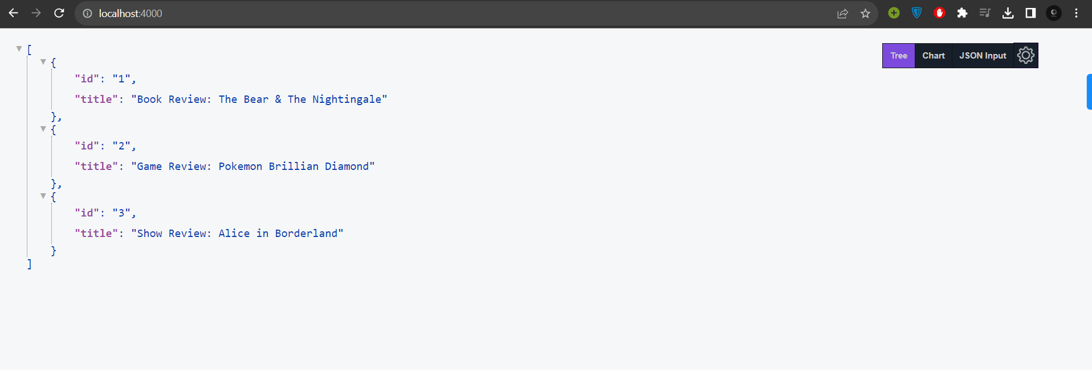

Conclusion: Thus I have run the node.js application on docker